**Arnav Singh**

**21113025**

**Civil 3rd year**

**B-Tech, IIT Roorkee**

**Title: Analysing a Simple Moving Average (SMA) Basic Strategy**

**Introduction:**

In this analysis, we explore the performance of a basic trading strategy based on a Simple Moving Average (SMA) basic approach. The hypothesis behind this strategy is that when the Closing Price falls below the short-term SMA, it indicates a potential buying opportunity, and conversely, when the short-term SMA crosses below the closing price, it signals a potential selling opportunity. We aim to evaluate the effectiveness of this strategy in generating returns using historical stock price data.

**Data Source and libraries**

Downloaded 10 years historical data of **Reliance Industries** from yahoo finance with a tick interval of 1 day. Used google data source: India Treasury Bills: Yield: 10 years(2013-2023) = 7.35%. Devised various mathematical functions

Used **Jupyter Notebook** for writing functions and used libraries such as **Pandas, Numpy, yfinance, matplotlib.** Created mathematical functions for analysis and calculating different metrics.

**Graphs for Stock Returns:**

To assess the performance of our SMA basic strategy, we first calculate the daily returns of a selected stock. Daily returns are calculated by taking the percentage change between consecutive days' prices. This is illustrated in the following graph, which shows the daily returns of the chosen stock over a specific time period.

**Graph for Portfolio Returns:**

Next, we implement our SMA basic strategy on the stock. We start with an initial capital and simulate the buying and selling of the stock based on the basic signals. The portfolio's daily returns are calculated, taking into account the changes in stock quantity and balance. The resulting portfolio returns are depicted in the graph below.

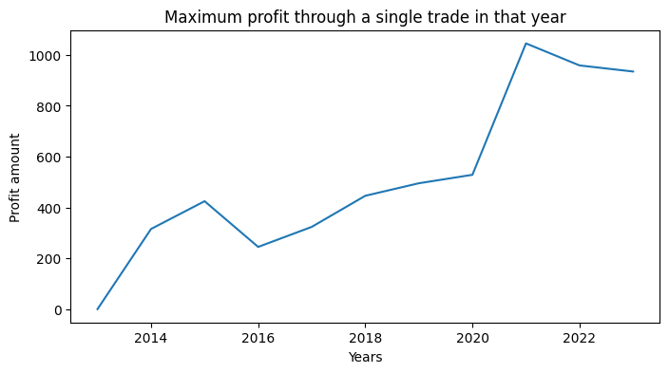

**Strategy Development:**

While this basic SMA basic strategy provides a starting point, there are several ways to further develop and enhance its performance. For instance, we can introduce risk management techniques, consider transaction costs, and explore variations in the choice of SMAs. Additionally, machine learning and statistical analysis can be applied to optimize the strategy's parameters and decision-making.

In the below graph : **Green marks**= **buy points** and **Red Marks = Sell Points**

**Insights Gained:**

The analysis has offered valuable insights into the effectiveness of the SMA basic strategy. By comparing portfolio returns to a benchmark or the market index, we can determine the relative performance of the strategy. Moreover, analysing the number of executed trades and calculating the win ratio provides an understanding of the strategy's practicality and profitability.

Initial portfolio value = 10,000.00

Final portfolio value = 23655.82435296607

Number of trades: 63

Maximum profit in a trade = 1045. 381488291575

Bench return of stock = 15.214438844632516

Sharpe Ratio: 0.7232217286515639

annual return: 12.740422905177562%

Strategy Return: 136.5582435296607%

Maximum drawdown: 25.05245817192334%

No. of wins = 63

No. of loss = 0

Win/loss ratio = infinite

Security = 100%

**Summary:**

In summary, our exploration of the SMA basic strategy highlights its potential as a basic trading approach. By visualizing stock returns, portfolio returns, and related performance metrics, we can assess its strengths and weaknesses. To enhance its effectiveness, strategy development and rigorous analysis are key. Ultimately, this analysis serves as a foundation for refining trading strategies and gaining valuable insights into their real-world application. This trading strategy gives you profit as well as 100% security.